Departamento de Informática – UTFSM
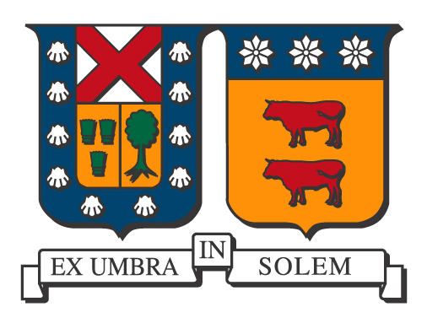
Ciclo de Coloquios 2018

El Departamento de Informática de la Universidad Técnica Federico Santa María tiene el agrado de invitar a la comunidad Universitaria a su ciclo de coloquios. Esta presentación se realizará en el Auditorio Claudio Matamoros (F-106), en la Casa Central el día martes 11 de septiembre las 11:45 y por videoconferencia a la Sala de Reuniones, Departamento de Informática, Campus San Joaquín, UTFSM.

Título

Facebook's GraphQL Framework and its Query Language

Expositor
Olaf Hartig
Assistant Professor in Computer Science at Linköping University, Sweden.
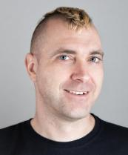

Mini Bio
Olaf is an Assistant Professor in Computer Science at Linköping University, Sweden. He has received several academic awards, including the 2015 Distinguished Dissertation Award of the Semantic Web Science Association and three best research paper awards (ESWC 2009, ESWC 2015, and ISWC 2017). Olaf's research interests are in problems related to the management of data and databases. His focus in this broad context is on data on the Web (Semantic Web and Linked Data, in particular) and on graph data, as well as on problems in which the data is distributed over multiple, autonomous and/or heterogeneous sources. Regarding all of these topics, Olaf's interests range from systems-building related research (e.g., efficient storage of datasets and databases, query processing, and query optimization) all the way to theoretical foundations (e.g., complexity and expressive power of query languages).

Resumen
After developing and using it internally for three years, in 2016, Facebook released a specification and a reference implementation of a framework, called GraphQL, that introduces a new type of Web-based data access interfaces. This framework has become highly popular and is employed by an increasing number of users including Coursera, Twitter, Github, Pinterest, and Medium. The framework includes a new graph query language which has been specified informally only. We have embarked on the formalization and the study of this language. In the talk I will provide an overview of the GraphQL framework and of the results of our work.

Lugar y Fecha
11 de septiembre de 2018, 11:45 hrs
Sala de Reuniones, Auditorio Claudio Matamoros (F-106), Casa Central, UTFSM.
La charla se transmitirá́ en videoconferencia a la sala de reuniones, Departamento de Informática, UTFSM, Campus San Joaquín.

